**Pseudocode & Examples**

An algorithm is a procedure for solving a problem in terms of the actions to be executed and the order in which those actions are to be executed.

An algorithm is merely the sequence of steps taken to solve a problem. The steps are normally "sequence," "selection, " "iteration," and a case-type statement.

Pseudocode is an artificial and informal language that helps programmers develop algorithms.

Pseudocode is a "text-based" detail (algorithmic) design tool.

The rules of Pseudocode are reasonably straightforward. All statements showing "dependency" are to be indented. These include while, do, for, if, switch. Examples below will illustrate this notion.

The rules of Pseudocode are reasonably straightforward. All statements showing "dependency" are to be indented. These include while, do, for, if, switch. Examples below will illustrate this notion.

**Note:** Pseudocode or Algorithms knows no language.

**Examples:**

**1.. If student's grade is greater than or equal to 60**

**Print "passed"**

**else**

**Print "failed"**

**2. Set total to zero**

**Set grade counter to one**

**While grade counter is less than or equal to ten**

**Input the next grade**

**Add the grade into the total**

**Set the class average to the total divided by ten**

**Print the class average.**

**3. Initialize total to zero**

**Initialize counter to zero**

**Input the first grade**

**while the user has not as yet entered the sentinel**

**add this grade into the running total**

**add one to the grade counter**

**input the next grade (possibly the sentinel)**

**if the counter is not equal to zero**

**set the average to the total divided by the counter**

**print the average**

**else**

**print 'no grades were entered'**

**4. initialize passes to zero**

**initialize failures to zero**

**initialize student to one**

**while student counter is less than or equal to ten**

**input the next exam result**

**if the student passed**

**add one to passes**

**else**

**add one to failures**

**add one to student counter**

**print the number of passes**

**print the number of failures**

**if eight or more students passed**

**print "raise tuition"**

**Things to note about pseudocode.**

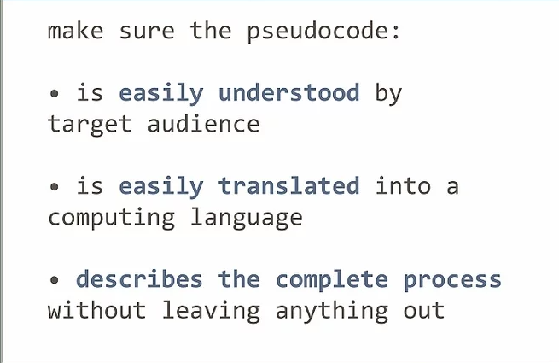

### 

### 

### 

### 

### 

### 

### 

### 

### 

### 

### 

### 

### **Pseudocode Examples**

### Add Two Numbers.

### Calculate Area and Perimeter of Rectangle (Simple Pseudocode Example)

### Find Area and Perimeter of a Square (Simple Pseudocode Example)

### Find Area Of Circle using Radius (Simple Pseudocode Example)

### Find Perimeter Of Circle using Radius (Simple Pseudocode Example)

### Calculate sales taxes (Simple Pseudocode Example)

### 

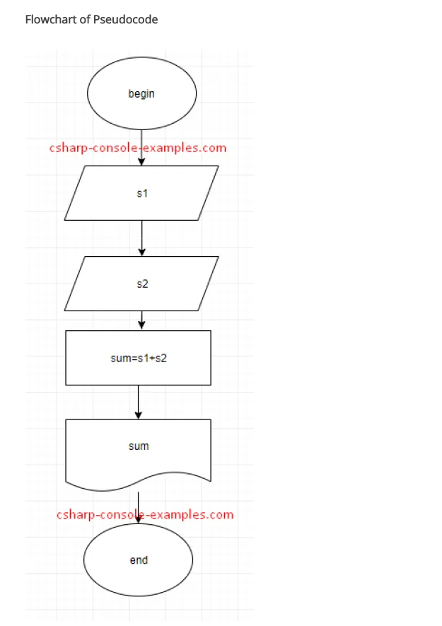

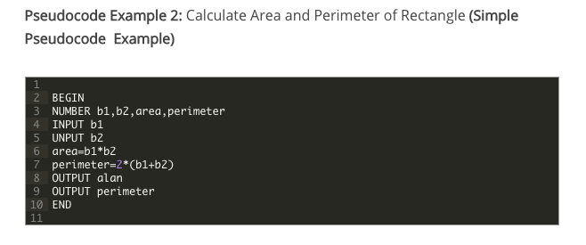

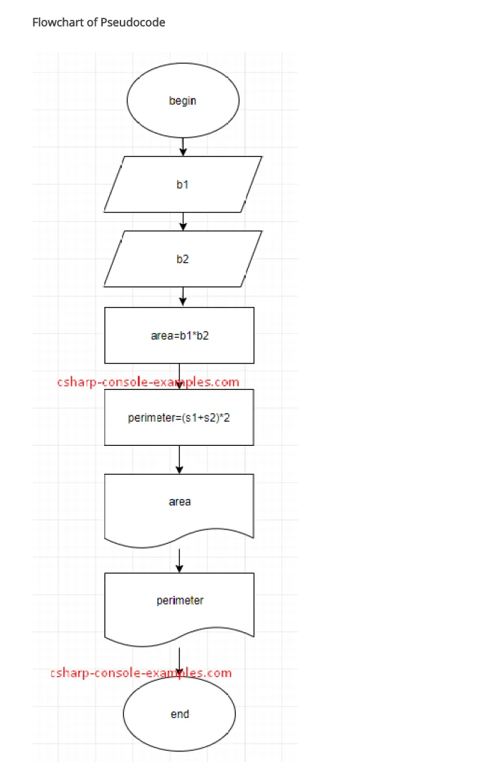

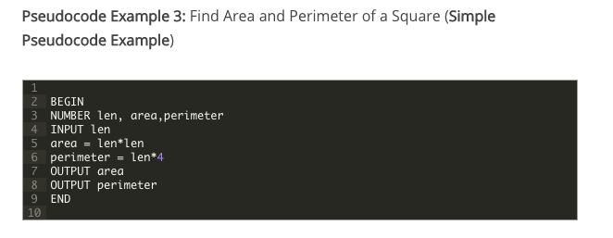

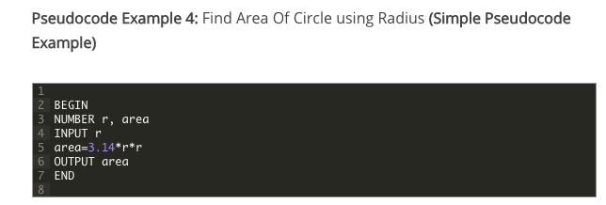

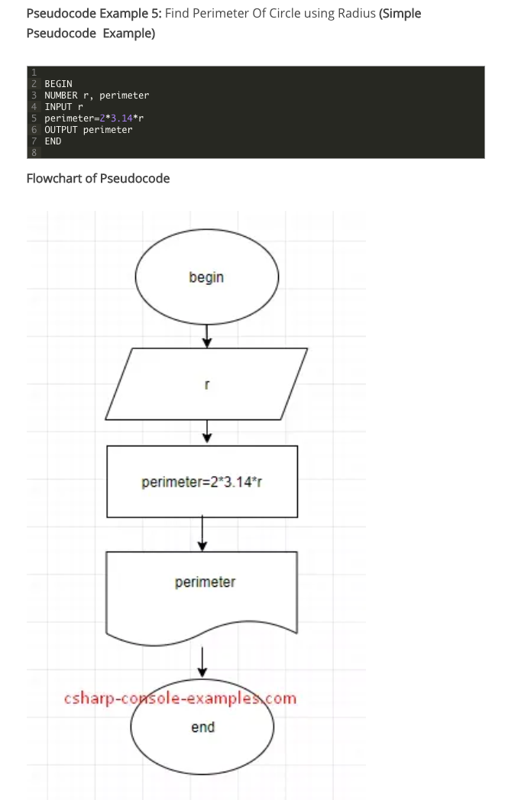

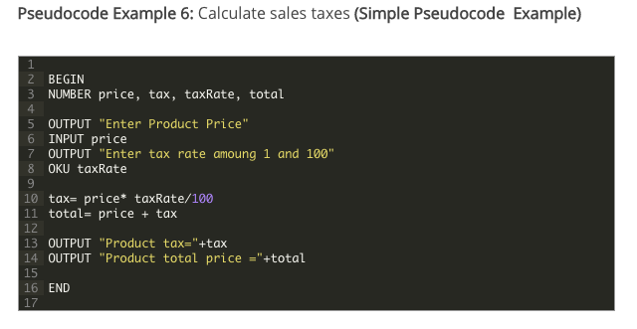

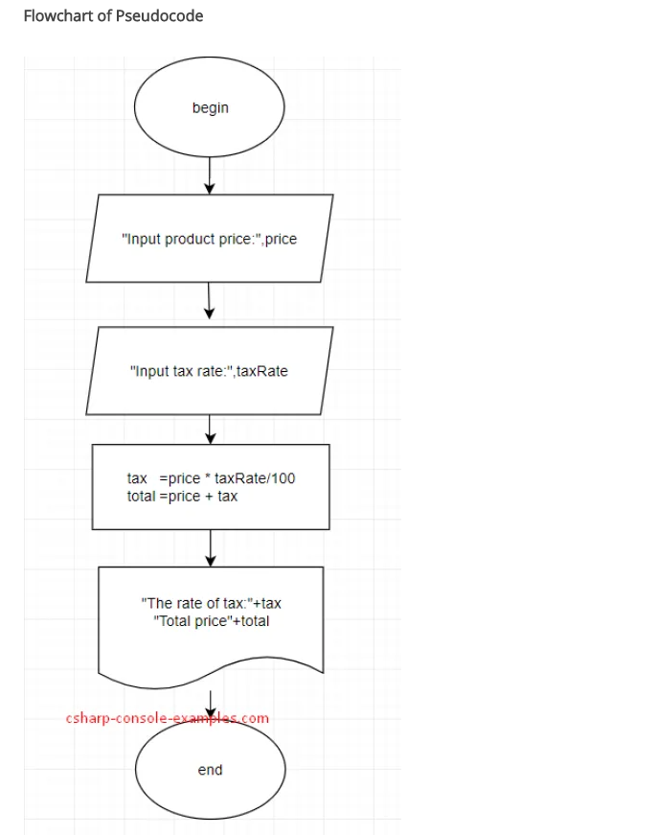

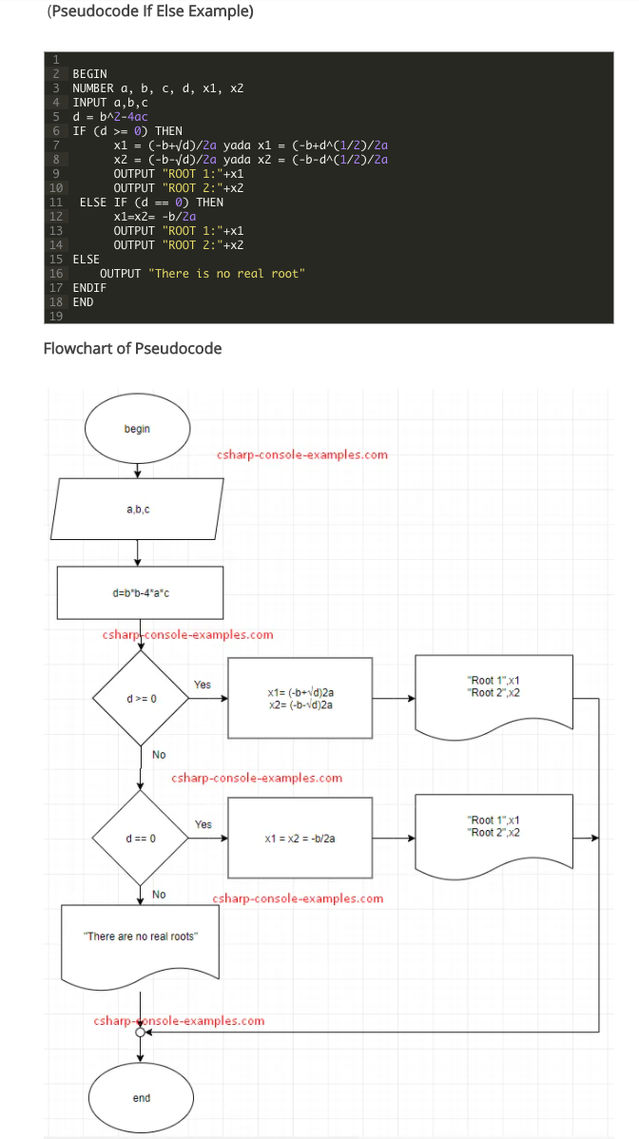

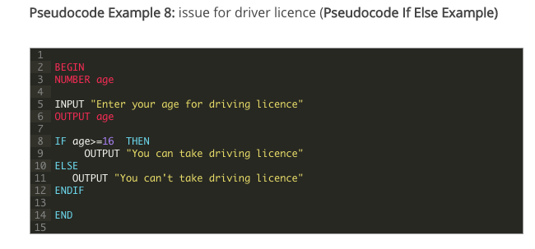

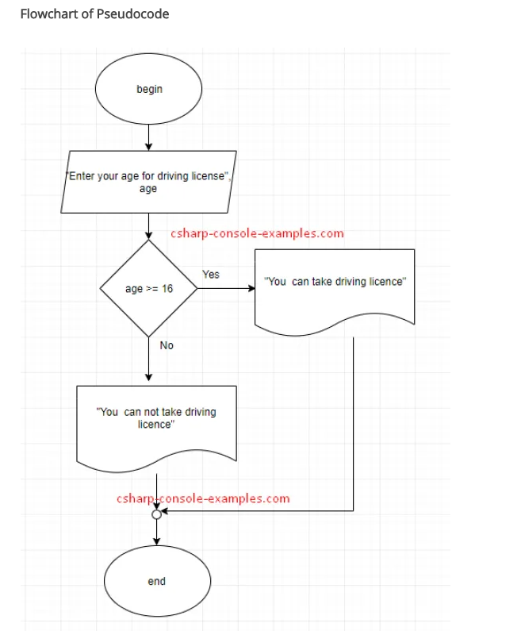

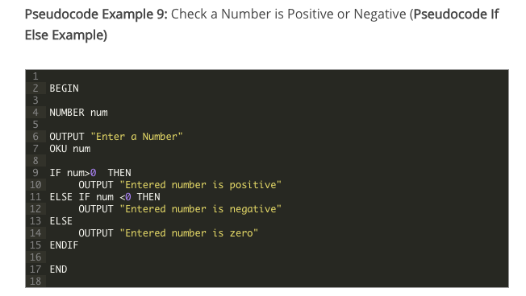

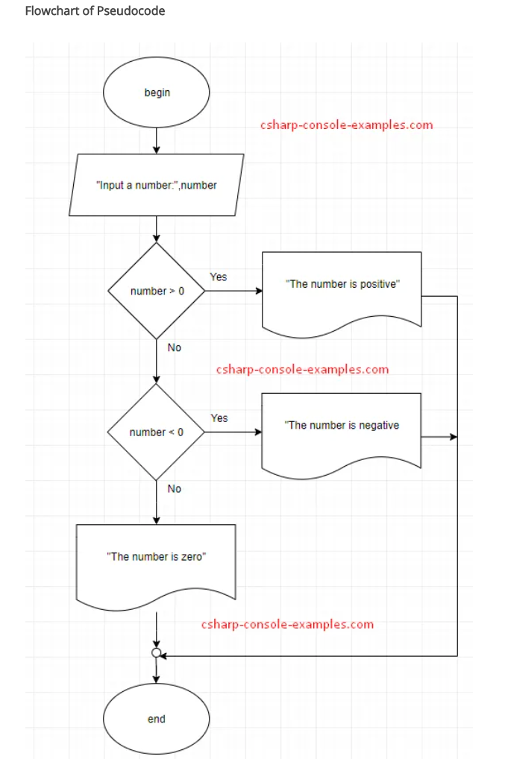

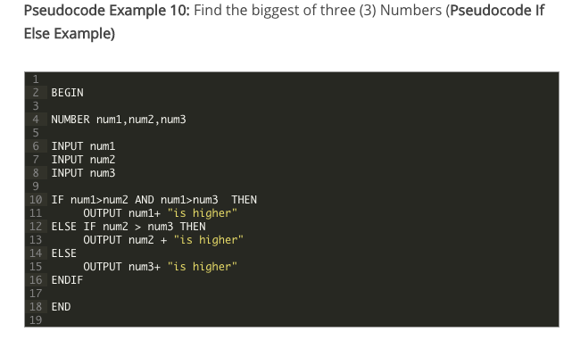

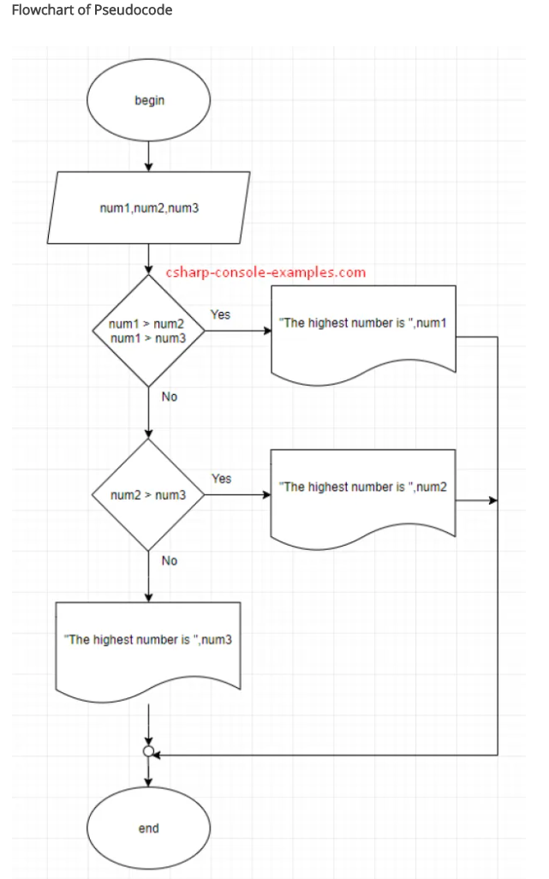

**Visit the Source for further reading:** https://cutt.ly/XfL86iS

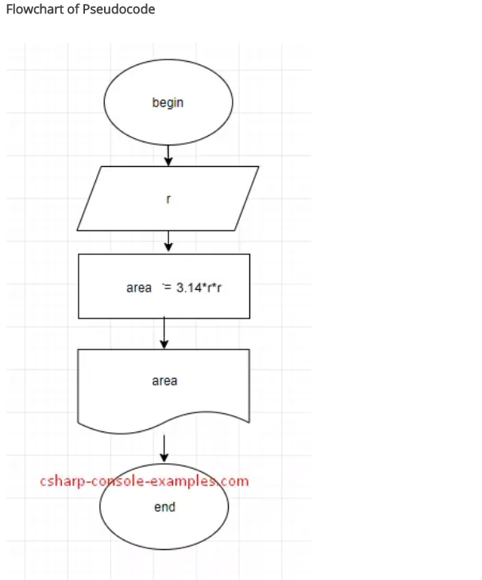

### **Some Keywords That Should be Used**

For looping and selection, The keywords that are to be used include Do While...EndDo; Do Until...Enddo; Case...EndCase; If...Endif; Call ... with (parameters); Call; Return ....; Return; When; Always use scope terminators for loops and iteration.

As verbs, use the words Generate, Compute, Process, etc. Words such as set, reset, increment, compute, calculate, add, sum, multiply, ... print, display, input, output, edit, test , etc. with careful indentation tend to foster desirable pseudocode.

Do not include data declarations in your pseudocode.

**Typical Examples:**



